SAVEETHA SCHOOL OF ENGINEERING
SAVEETHA INSTITUTE OF MEDICAL AND TECHNICAL SCIENCES
INSTITUTE OF CSE
CSA15- CLOUD COMPUTING AND BIG DATA ANALYTICS
LIST OF EXPERIMENTS
8. Create a simple cloud web application for student counselling system using any Cloud
Service Provider to demonstrate SaaS with the fields of student name, age, address,
phone, subjects studied, Year of passing, percentage of marks, domain interest, etc.
INPUT:

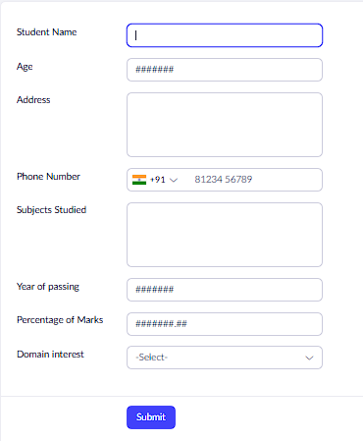

OUTPUT:
